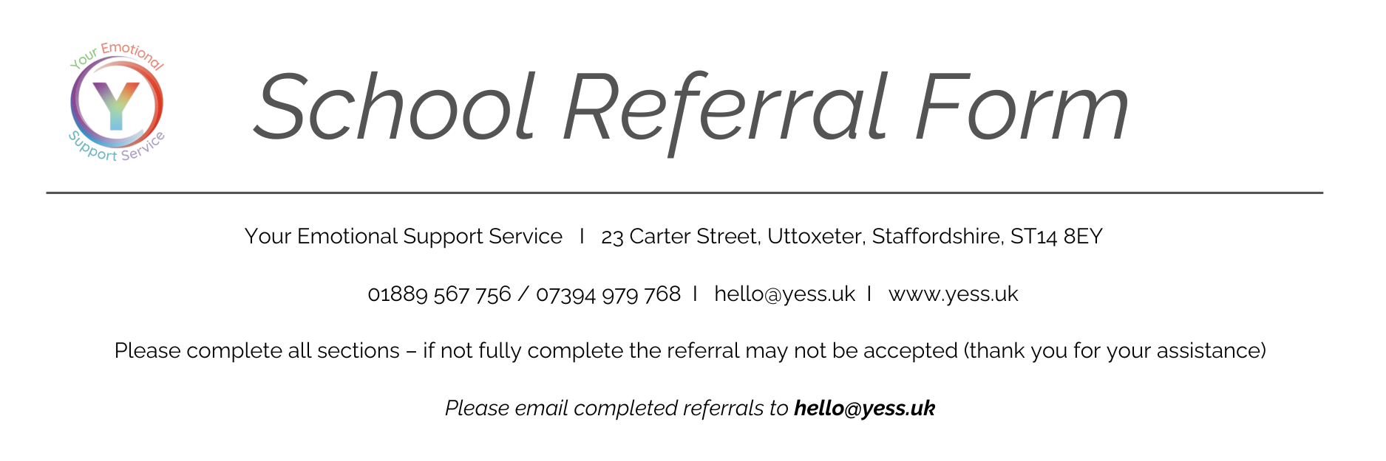
CONSENT (Please complete fully)
Parent/Carer Consent
Have you gained consent from the parent or carer regarding this referral? | 0 Yes, they agree  0 No, I have not asked them
Does the parent or carer consent to YESS storing their data? (a copy of our privacy policy is on our website or can be requested by email to hello@yess.uk) | YES NO
Does the parent or carer consent to YESS contacting them for marketing & Development purposes? (THIS CONSENT CAN BE WITHDRAWN AT ANYTIME) | YES NO
IF YES, HOW WOULD THE PARENT/CARER LIKE US TO CONTACT THEM? | PHONE EMAIL

CONSENT (Please complete fully)
Young Person Consent (if over the age of 14 years and/or Frazer Competency, Young Person can consent to referral themselves)
Have you gained consent from the young person, regarding this referral? | 0 Yes, they agree  0 No, I have not asked them
Does the child/young person have Frazer competency? | YES NO
Does the young person consent to YESS contacting the parent/carer (if needed) regarding this referral and ongoing therapy? | 0 Yes, they agree  0 No  0 I have not asked them
Does the young person consent to YESS storing their data? (a copy of our privacy policy is on our website or can be requested by email to hello@yess.uk) | YES NO
Does the young person consent to YESS contacting them for marketing & Development purposes? (THIS CONSENT CAN BE WITHDRAWN AT ANYTIME) | YES NO
IF YES, HOW WOULD THE YOUNG PERSON LIKE US TO CONTACT THEM? | PHONE EMAIL

CLIENT DETAILS (please complete as fully as possible)

Name:  DOB:  Age:  Gender:  Gender Identity:  Preferred Pronouns:  Ethnicity:  GP Surgery:  School/College: | Address:  Contact to arrange appointments:  Name:  Contact Telephone Number:  Relationship to Child or Young Person:

PLEASE COMPLETE BOTH PARENT DETAILS IF SEPARATED AND PARENTAL RESPONSIBILITY IS GIVEN TO BOTH
Parent/Carer Name: |  |  |  |  | Relationship
Tel |  | Mob |  | E-mail
Parent/Carer Name: |  |  |  |  | Relationship
Address (if different from above)

Tel |  | Mob |  | E-mail

C&YP Referrals only | Yes | No | Details
Are there current safeguarding concerns?
Please indicate first language
Is there a physical, sensory or learning disability?
Are there issues relating to ethnicity or culture?
Are there issues relating to gender or sexuality?
Other: Please indicate
Other professionals involved with family

Please provide a reason for the referral, please also provide an overview of any difficulties and any areas of risk, (such as self-harm or suicide ideation):
FUNDING (Please Indicate)

SERVICE LEVEL AGREEMENT (SLA) SPOT PROVISION (NOT SLA)

MAIN ISSUES – Please tick all that apply
 | Self Harm |  | Family Breakdown/Relationship |  | Tics
 | Anxiety |  | Neglect or Abuse |  | ADHD
 | Low Mood |  | Behavioural |  | Attachment Difficulties
 | Suicidal Thoughts |  | Domestic Violence |  | Substance Misuse
 | Loss or Bereavement |  | Issues Around Sexuality |  | Addiction
 | Bullying |  | Pregnancy or Related Issues |  | Eating Disorders
 | Illness of Self |  | Relationships |  | Phobias
 | Illness of Others |  | Self Esteem |  | OCD
 | Anger |  | Sleep Problems |  | Other (please specify)
 | School Issues/ Refusal |  | Autistic Spectrum Disorder

Referrer’s Name |  |  | Position
Agency
Address
Contact Tel No |  | Email
Signed |  | Date

